Guillaume Minette de Saint Martin

Advanced data Technologies
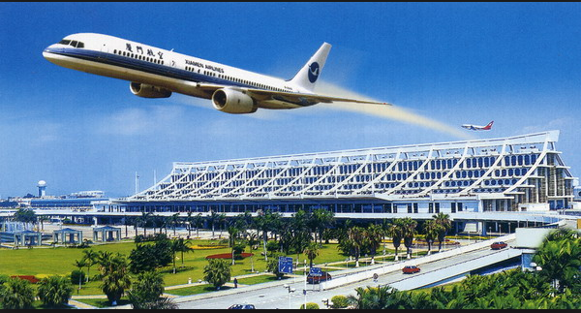

Lab 5

Table of contents
Drawings 3
Tables creation 3
Tables 3
SQL code 4
Metadata insertion 5
Data insertion 6
Indexes creation 10
Result 10
SQLDeveloper map view 10
GeoRaptor view 12
Observations 12
Spacial queries 13
Links 19

Drawings

The designed tables will describe informations about the geography of an airport.
For this, we can identify runways and airplanes but also roads and cars as well as buildings and trees.

There is the Georaptor display of the airport drawing
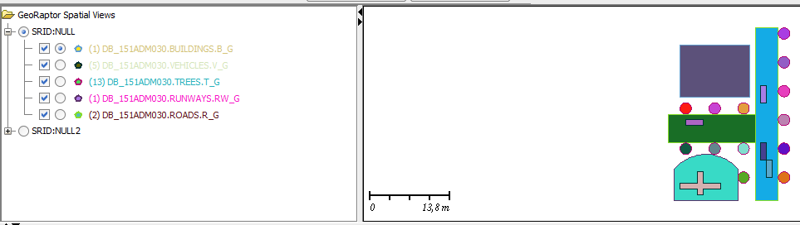

Tables creation

Tables

In order to store informations in database, several layers are created to store the different objects.
These layouts are stored in tables which correspond to the different types of objects represented in the database.

Tables are the following:

- Roads
- Buildings
- Trees
- Runways
- Vehicles

SQL code

Each table contains 3 columns: an id, a name and the geometry item.
Sequences are used to automatically fill the id fields during inserts.
Roads

CREATE TABLE roads (
id NUMBER,
name VARCHAR2(50),
r_g SDO_GEOMETRY );

Buildings

CREATE TABLE buildings (
id NUMBER,
name VARCHAR2(50),
b_g SDO_GEOMETRY );

Trees

CREATE TABLE trees (
id NUMBER,
name VARCHAR2(50),
t_g SDO_GEOMETRY );

Runways

CREATE TABLE runways (
id NUMBER,
name VARCHAR2(50),
rw_g SDO_GEOMETRY );

Vehicles

CREATE TABLE vehicles (
id NUMBER,
name VARCHAR2(50),
v_g SDO_GEOMETRY );

Sequences
create sequence roads_seq;
create sequence buildings_seq;
create sequence trees_seq;
create sequence runways_seq;
create sequence vehicles_seq;

Metadata insertion

For each table, metadata are inserted in order to specify the dimensions of the two axis used to display the spacial figures.

Roads
INSERT INTO USER_SDO_GEOM_METADATA(TABLE_NAME, COLUMN_NAME, DIMINFO, SRID)
VALUES('roads', 'r_g',MDSYS.SDO_DIM_ARRAY(
MDSYS.SDO_DIM_ELEMENT('X', 0, 30, 1),
MDSYS.SDO_DIM_ELEMENT('Y', 0, 30, 1)),
NULL);

Buildings
INSERT INTO USER_SDO_GEOM_METADATA(TABLE_NAME, COLUMN_NAME, DIMINFO, SRID)
VALUES('buildings', 'b_g',MDSYS.SDO_DIM_ARRAY(
MDSYS.SDO_DIM_ELEMENT('X', 0, 30, 1),
MDSYS.SDO_DIM_ELEMENT('Y', 0, 30, 1)),
NULL);

Trees
INSERT INTO USER_SDO_GEOM_METADATA(TABLE_NAME, COLUMN_NAME, DIMINFO, SRID)
VALUES('trees', 't_g',MDSYS.SDO_DIM_ARRAY(
MDSYS.SDO_DIM_ELEMENT('X', 0, 30, 1),
MDSYS.SDO_DIM_ELEMENT('Y', 0, 30, 1)),
NULL);

Runways
INSERT INTO USER_SDO_GEOM_METADATA(TABLE_NAME, COLUMN_NAME, DIMINFO, SRID)
VALUES('runways', 'rw_g',MDSYS.SDO_DIM_ARRAY(
MDSYS.SDO_DIM_ELEMENT('X', 0, 30, 1),
MDSYS.SDO_DIM_ELEMENT('Y', 0, 30, 1)),
NULL);

Vehicles
INSERT INTO USER_SDO_GEOM_METADATA(TABLE_NAME, COLUMN_NAME, DIMINFO, SRID)
VALUES('vehicles', 'v_g',MDSYS.SDO_DIM_ARRAY(
MDSYS.SDO_DIM_ELEMENT('X', 0, 30, 1),
MDSYS.SDO_DIM_ELEMENT('Y', 0, 30, 1)),
NULL);

Data insertion

In each table, at least one item is inserted.

Roads
This table uses rectangles to draw roads, it Is therefore needed to input two points to draw it: the lower left and the upper right: example sdo_ordinate_array (15,0, 19,30).
INSERT INTO roads (id, name, r_g) VALUES (roads_seq.nextval, 'road1',sdo_geometry (2003, null, null,
sdo_elem_info_array (1,1003,3),
sdo_ordinate_array (15,0, 19,30)));
INSERT INTO roads (id, name, r_g) VALUES (roads_seq.nextval, 'road2',sdo_geometry (2003, null, null,
sdo_elem_info_array (1,1003,3),
sdo_ordinate_array (0,10, 15,15)));

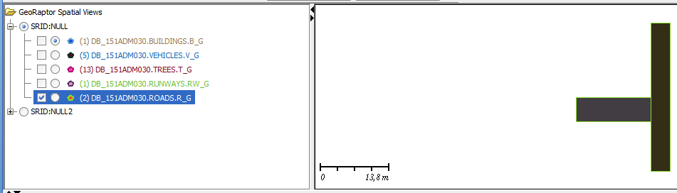Roads graphical display
Buildings
This table uses rectangles to draw buildings, buildings are then also drawn according to their lower left and upper right point: example: sdo_ordinate_array (2,18, 14,27).
INSERT INTO buildings (id, name, b_g) VALUES (buildings_seq.nextval, 'building1',sdo_geometry (2003, null, null,
sdo_elem_info_array (1,1003,3),
sdo_ordinate_array (2,18, 14,27)));

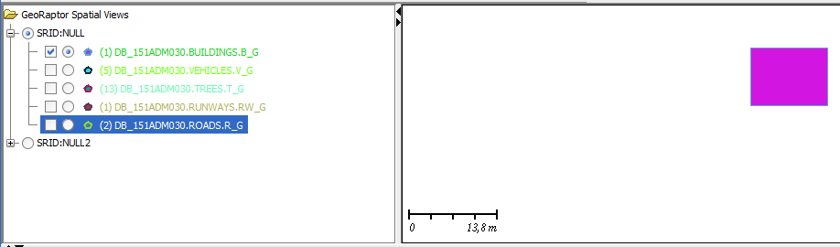Buildings graphical display
Trees
This table uses circles to draw trees, trees are then drawn according to their diameter's coordinates as well as the coordinates of their centre point: example: sdo_ordinate_array (3,17, 4,16, 3,15).
INSERT INTO trees (id, name, t_g) VALUES (trees_seq.nextval, 'tree1',sdo_geometry (2003, null, null,
sdo_elem_info_array (1,1003,4),
sdo_ordinate_array (3,17, 4,16, 3,15)));
INSERT INTO trees (id, name, t_g) VALUES (trees_seq.nextval, 'tree2',sdo_geometry (2003, null, null,
sdo_elem_info_array (1,1003,4),
sdo_ordinate_array (8,17, 9,16, 8,15)));
INSERT INTO trees (id, name, t_g) VALUES (trees_seq.nextval, 'tree3',sdo_geometry (2003, null, null,
sdo_elem_info_array (1,1003,4),
sdo_ordinate_array (13,17, 14,16, 13,15)));
INSERT INTO trees (id, name, t_g) VALUES (trees_seq.nextval, 'tree4',sdo_geometry (2003, null, null,
sdo_elem_info_array (1,1003,4),
sdo_ordinate_array (3,10, 4,9, 3,8)));
INSERT INTO trees (id, name, t_g) VALUES (trees_seq.nextval, 'tree5',sdo_geometry (2003, null, null,
sdo_elem_info_array (1,1003,4),
sdo_ordinate_array (8,10, 9,9, 8,8)));
INSERT INTO trees (id, name, t_g) VALUES (trees_seq.nextval, 'tree6',sdo_geometry (2003, null, null,
sdo_elem_info_array (1,1003,4),
sdo_ordinate_array (13,10, 14,9, 13,8)));
INSERT INTO trees (id, name, t_g) VALUES (trees_seq.nextval, 'tree7',sdo_geometry (2003, null, null,
sdo_elem_info_array (1,1003,4),
sdo_ordinate_array (13,5, 14,4, 13,3)));
INSERT INTO trees (id, name, t_g) VALUES (trees_seq.nextval, 'tree8',sdo_geometry (2003, null, null,
sdo_elem_info_array (1,1003,4),
sdo_ordinate_array (20,5, 21,4, 20,3)));
INSERT INTO trees (id, name, t_g) VALUES (trees_seq.nextval, 'tree9',sdo_geometry (2003, null, null,
sdo_elem_info_array (1,1003,4),
sdo_ordinate_array (20,10, 21,9, 20,8)));
INSERT INTO trees (id, name, t_g) VALUES (trees_seq.nextval, 'tree10',sdo_geometry (2003, null, null,
sdo_elem_info_array (1,1003,4),
sdo_ordinate_array (20,15, 21,14, 20,13)));
INSERT INTO trees (id, name, t_g) VALUES (trees_seq.nextval, 'tree11',sdo_geometry (2003, null, null,
sdo_elem_info_array (1,1003,4),
sdo_ordinate_array (20,20, 21,19, 20,18)));
INSERT INTO trees (id, name, t_g) VALUES (trees_seq.nextval, 'tree12',sdo_geometry (2003, null, null,
sdo_elem_info_array (1,1003,4),
sdo_ordinate_array (20,25, 21,24, 20,23)));
INSERT INTO trees (id, name, t_g) VALUES (trees_seq.nextval, 'tree13',sdo_geometry (2003, null, null,
sdo_elem_info_array (1,1003,4),
sdo_ordinate_array (20,30, 21,29, 20,28)));
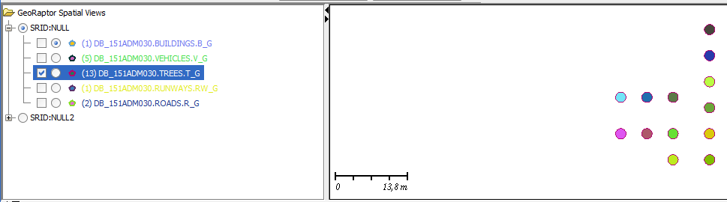Trees graphical display
Runways
This table uses compound polygons (to include curves) to draw runways, runways are then drawn according to their different point's coordinates as well as the coordinates describing the curved line: example: sdo_ordinate_array (1,5.5, 1,0, 12,0, 12,5.5, 6,8, 1,5.5).
INSERT INTO runways (id, name, rw_g) VALUES (runways_seq.nextval, 'runway1',sdo_geometry (2003, null, null,
sdo_elem_info_array (1,1005,2, 1,2,1, 7,2,2),
sdo_ordinate_array (1,5.5, 1,0, 12,0, 12,5.5, 6,8, 1,5.5)));

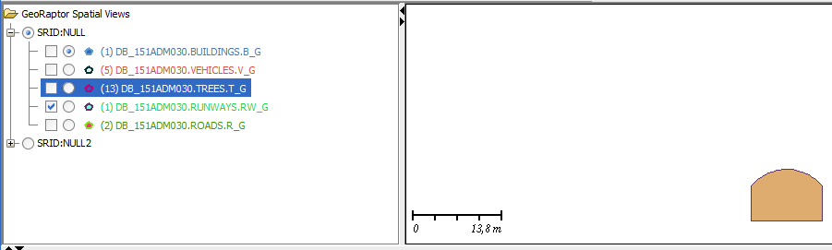Runway graphical display
Vehicles
This table uses simple polygons to draw vehicles, vehicles are then drawn according to their different point's coordinates: example: sdo_ordinate_array (17,4, 18,4, 18,7, 17,7, 17,4).
INSERT INTO vehicles (id, name, v_g) VALUES (vehicles_seq.nextval, 'car1',sdo_geometry (2003, null, null,
sdo_elem_info_array (1,1003,1),
sdo_ordinate_array (17,4, 18,4, 18,7, 17,7, 17,4)));

INSERT INTO vehicles (id, name, v_g) VALUES (vehicles_seq.nextval, 'car2',sdo_geometry (2003, null, null,
sdo_elem_info_array (1,1003,1),
sdo_ordinate_array (16,7, 17,7, 17,10, 16,10, 16,7)));

INSERT INTO vehicles (id, name, v_g) VALUES (vehicles_seq.nextval, 'car3',sdo_geometry (2003, null, null,
sdo_elem_info_array (1,1003,1),
sdo_ordinate_array (16,17, 17,17, 17,20, 16,20, 16,17)));

INSERT INTO vehicles (id, name, v_g) VALUES (vehicles_seq.nextval, 'car4',sdo_geometry (2003, null, null,
sdo_elem_info_array (1,1003,1),
sdo_ordinate_array (3,13, 6,13, 6,14, 3,14, 3,13)));

INSERT INTO vehicles (id, name, v_g) VALUES (vehicles_seq.nextval, 'plane1',sdo_geometry (2003, null, null,
sdo_elem_info_array (1,1003,1),
sdo_ordinate_array (2,3, 2,2, 5,2, 5,1, 6,1, 6,2, 9,2, 9,3, 6,3, 6,5, 5,5, 5,3,2,3)));

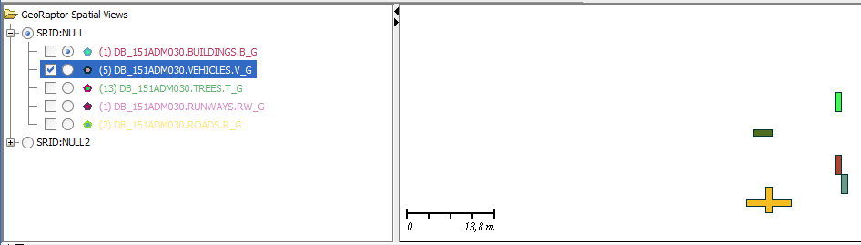Vehicles graphical display

Indexes creation

In order to be displayed correctly, layouts have to be indexed, therefore indexes are created, they describe the way layers are displayed relatively to each other.

SQL code
create index IND_buildings on buildings(b_g) indextype is MDSYS.SPATIAL_INDEX;
create index IND_trees on trees(t_g) indextype is MDSYS.SPATIAL_INDEX;
create index IND_runways on runways(rw_g) indextype is MDSYS.SPATIAL_INDEX;
create index IND_vehicles on vehicles(v_g) indextype is MDSYS.SPATIAL_INDEX;
create index IND_roads on roads(r_g) indextype is MDSYS.SPATIAL_INDEX;

Result

There is two ways to display the results: the map view thanks to SQLDeveloper and the GeoRaptor display.

SQLDeveloper map view
To achive this result, the querries details are:
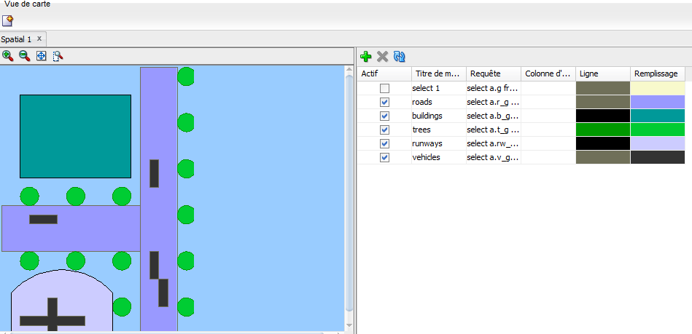Map view according to SQLDeveloper

true | roads | select a.r_g from roads a |  | java.awt.Color[r=112,g=112,b=89] | java.awt.Color[r=153,g=153,b=255]

true | buildings | select a.b_g from buildings a |  | java.awt.Color[r=0,g=0,b=0] | java.awt.Color[r=0,g=153,b=153]

true | trees | select a.t_g from trees a |  | java.awt.Color[r=0,g=153,b=0] | java.awt.Color[r=0,g=204,b=51]

true | runways | select a.rw_g from runways a |  | java.awt.Color[r=0,g=0,b=0] | java.awt.Color[r=204,g=204,b=255]

true | vehicles | select a.v_g from vehicles a |  | java.awt.Color[r=112,g=112,b=89] | java.awt.Color[r=51,g=51,b=51]

GeoRaptor view
GeoRaptor simultaneous display of all tables

Observations
We can see according to these two display that the GeoRaptor tool provides additional informations by providing the scale of the display, it also allows to draw figures.
Nevertheless it seems to be a little problem of compatibility somewhere between GeoRaptor and this version of Java resulting an unexpectingly changing color display of all items in the same layout.

Spacial queries

Inspect metadata
select * from USER_SDO_GEOM_METADATA;
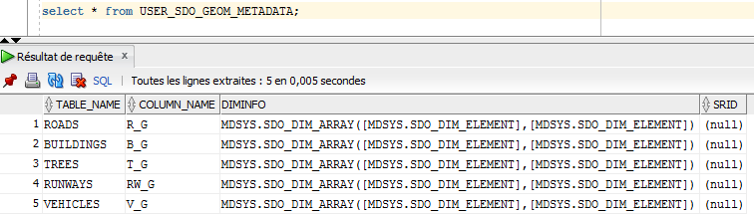
We can see here that all tables have a line in the geometrical meta data and their geomety object is also present.

Inspect indexes
select * from ALL_SDO_INDEX_INFO;
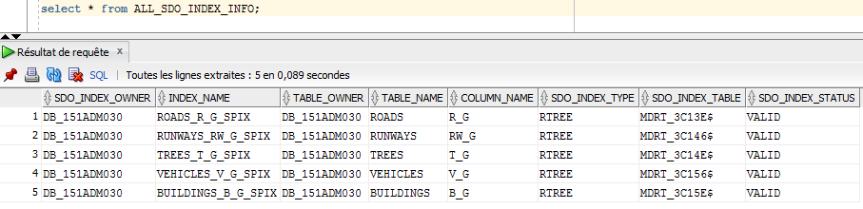
We can see here that all tables have a line in the indexes table, we can also notice that all trees are RTREE, the default type.

Finding which figures are interacting wih the figure named Road1
SELECT r.name, v.name
FROM vehicles v, roads r
WHERE r.NAME = 'road1' AND
SDO_FILTER(v.v_g, r.r_g) = 'TRUE';
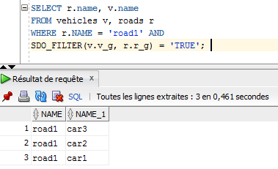
We can see that cars number 1, 2 and 3 are interacting with the road1.
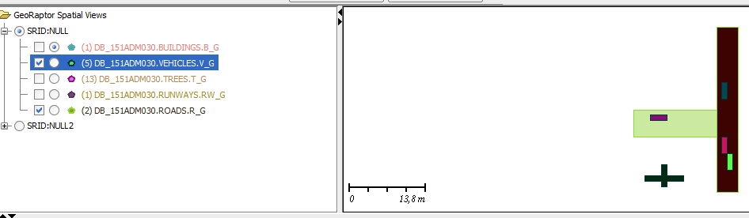
Indeed, they do, road1 is the one on the right and cars 1, 2 and 3 are the left ones too.

Computing distance between two items

Distance between the building and all vehicles

SELECT v.NAME, B.NAME, SDO_GEOM.SDO_DISTANCE(v.v_g,b.b_g,0.0005) AS distance
FROM vehicles V,buildings B;
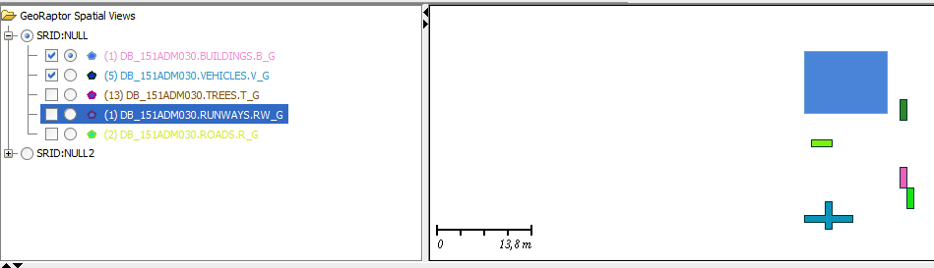
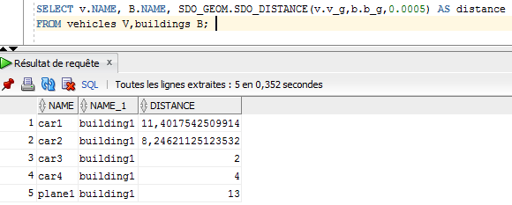

Distance between the plane and all trees
SELECT v.NAME, t.NAME, SDO_GEOM.SDO_DISTANCE(v.v_g,t.t_g,0.0005) AS distance
FROM vehicles V,trees t
WHERE v.name='plane1';
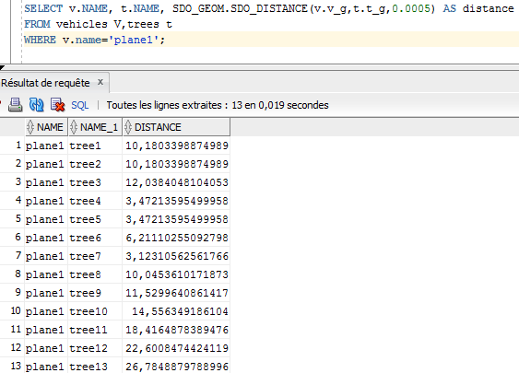
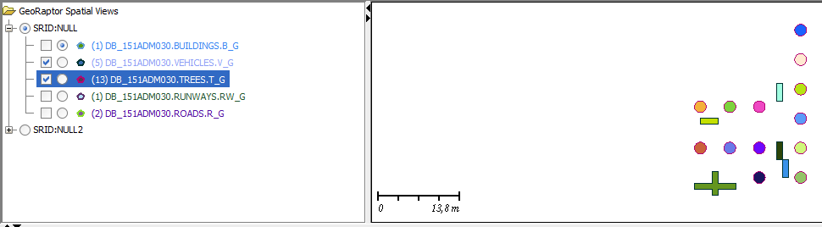

Vehicles and runways which has at least one intercation of any type:
SELECT v.name,r.name
FROM vehicles v, runways r
WHERE SDO_RELATE(v.v_g, r.rw_g, 'MASK=ANYINTERACT')='TRUE';

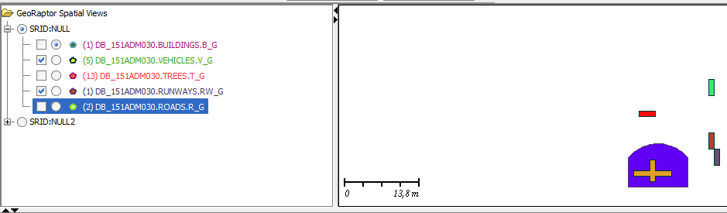
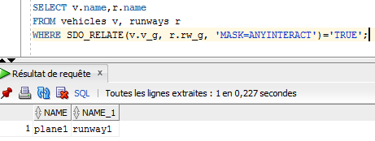
Items which are touching each other:

Vehicles which are touching each other
SELECT v.name, w.name
FROM vehicles v, vehicles w
WHERE MDSYS.SDO_TOUCH(v.v_g, w.v_g) = 'TRUE';
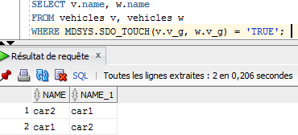
Roads which are touching each other
SELECT r.name, s.name
FROM roads r, roads s
WHERE MDSYS.SDO_TOUCH(r.r_g, s.r_g) = 'TRUE';
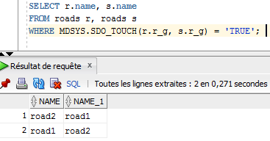

Links
1st page picture:
http://www.localtrips.net/

